RESUME

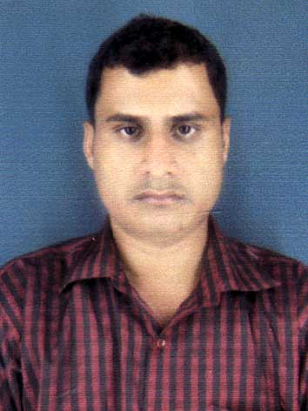

Pranab Kumar Mohapatra
E-mail:-pranabmohapatra5@gmail.com
MOBILE:-918093443788
Career Objectives:
To be a part of forward looking, strategic decision making, leading and self develop as well as acting positively with honestly towards my duty which ultimately lead to active the objective.

Educational Qualification:
2005 10TH :-2nd Division
2008 +2:(science) -3nd Division
2011 +3:(B.SC )-2nd Division
2014: MBA( dual Specialization:MARKETING&HR)
Strength:
Self confidence
Hardworking and eager to be a learn
Work Experience
- 1 year worked as a MIS Executive at Roto power pvt.ltd.
- 1 year Experience in VIVO Mobile as a promotion executive.

Personal Profile:

Name : Pranab kumar mohapatra
Father's Name Pitambar mohapatra
Permanent Addess : At :Simulipal
Po: Nadabani
Ps-Singla
Dist-Balasore
Pin: 756024
Sex : Male
Religion : Hindu
Nationality : Indian
Date of Birth : 10TH Feb. 1989
Languages known : Oriya, Hindi & English

Declaration:

I hereby declare that the above mentioned information is correct up to my knowledge and I bear the responsibility for the correctness of the above mentioned particulars.

Place :

Date :
Signature

